Prijavni list
seminar za voditelje „relaksacija smijehom-yoga smijeha“ 25. i 26.11.2023.g.

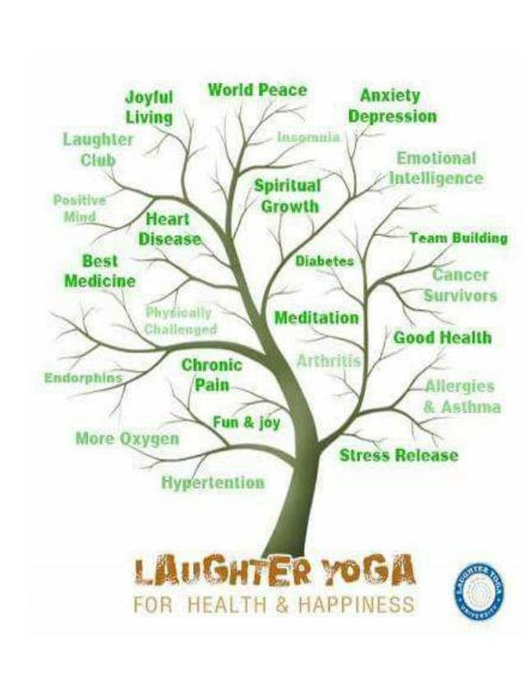

Ime i prezime:_______________________________________________________________

God.rođenja:___________________ OIB:________________________________________

Adresa:_____________________________________________________________________

Tel/mob.:______________________ mail:____________________________

Zanimanje:__________________________________________________________________

Interesi:_____________________________________________________________________

Motiv za prijavu na seminar:____________________________________________________________________

Datum:________________________



